Notes for pythonguis.com
BASICS
- QtWidgets contains a bunch of classes useful for creating an application.
- The main modules for Qt are QtWidgets, QtGui and QtCore.
- app = QApplication() is an instance of QApplication
- by calling <import sys>, we can use sys.argv as a parameter for QApplication if our application requires command line arguments.
- sys.argv contains a list of command line arguments.
- In Qt, all top level widgets are windows.
- A window:
- Holds application UI
- Every application needs at least one but can have more
- Application exits when the last window is closed.
- .show() method is a widget/window method for making the window visible during application execution.
- Event loop:
- When the user interacts with out application, an event is generated
- The event is placed on an event queue.
- The queue passes events to the event loop.
- If a waiting loop is encountered, it is passed to the appropriate event handler
- After the event is handled, event loop takes over control waiting for another event.
- This process continues.
- There can be only one running event loop per application.
- 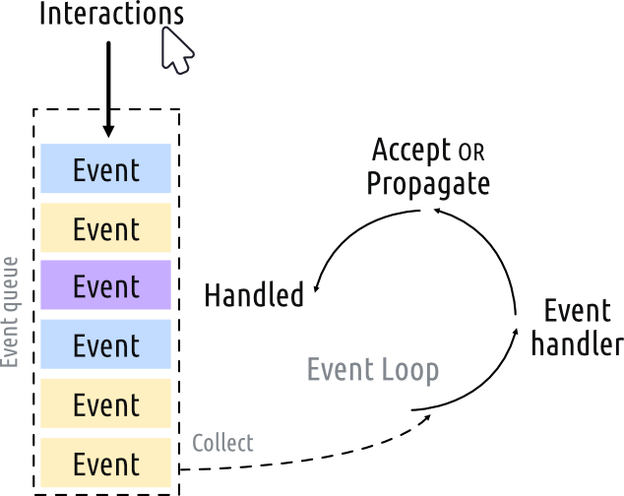
- QApplication holds the Qt event loop.
- .exec() method of QApplication starts the event loop.
- We define subclass MainWindow of QMainWindow because we want to create custom windows with custom functionality.
- From PyQt6.QtCore import Qt, the Qt namespace stores all qt constants and identifiers. Example: Qt.MouseButton

QtWidget
- QApplication
  - application handler
  - QApplication(sys.argv) if command line arguments are needed.
  - QApplication([]) if not
  - .exec() method starts the event loop
- QMainWindow
  - Qt’s default window class
  - .setWindowTitle() changes the title of the main window.
- QWidget
  - A UI Element
  - All top level widgets behave as a “window”
- QPushButton
  - A button widget.
  - Takes a string parameter. Shows the string over the button
- QLabel
  - Text display
- QLineEdit
  - Text input box

QtCore
- QSize
  - Initialized with width(x) and height(y) parameters in that order.

Widget Methods
- .setCentralWidget(<widget>)
  - places a widget at the middle of the window. By default, it takes self.
  - The widget resizes alongside the window.
- .setFixedSize(<QSize>)
  - will create a fixed window size.
- .setMinimumSize(<QSize>), .setMaximumSize(<QSize>)
- .setCheckable(<bool>)
  - <bool> can be set to True or False and accordingly,
  - Gives widgets an on(True) or off(False) state.
- .setChecked (<bool>)
  - Set the state(True or False) for widget
- .setEnabled(<bool>), .setDisabled(<bool>)
- .setText(<string>)
  - change the text in widget
- .setLayout(<layout_object>)
  - Takes a layout object as parameter and lays out the widgets within the layout accordingly in the outer widget.
- setMouseTracking(True)
  - allows widgets to detect mouseMoveEvent even when a button on the mouse is not clicked
  - must be called for both window and widget

Signals, Slots and Events
- Signals are notifications emitted by widgets when an something happens.
- This may include notifying that an event occurred or data being sent to provide additional context
- Built-in and custom signals
  - QPushButton.clicked
    - Mouse clicks the button and releases while it is still within the border of the button.
    - Signal sends a <bool> argument
  - QPushButton.released
    - Mouse clicks and is released anywhere.
    - Signal does not send a <bool> argument
  - QMainWindow.windowTitleChanged
    - Title of the main window is changed.
    - New title is different from old title
  - QLineEdit.textChanged
    - Text in the input box is changed
    - Signal sends the text within as argument

- Stots are signal receivers.
- Any function can be used as a slot by connecting a signal to it.

- Events are every interaction that the user has with a Qt application.
- Represented with event objects.
- Events are passed to event handlers which are methods of widgets
- Can define custom event handlers by overriding the event through subclasses
- Event name must remain same.
  - QMouseEvents
    - mouseMoveEvent
    - mousePressEvent
    - mouseReleaseEvent
    - mouseDoubleClickEvent
    - Qt.MouseButton.(LeftButton/RightButton/MiddleButton/NoButton) (NOTE: MoveEvent does not take buttons.)
    - .button()
      - Returns the button that triggered this event
    - .buttons()
      - Returns the state of all mouse buttons
    - .position()
      - Widget-relative position of the mouse cursor as a QPoint integer

